XCore File Uploader – SPEAK App

# Introduction

XCore’s file uploader control extends Sitecore’s [Uploader](http://sdn.sitecore.net/upload/sitecore7/75/speak_component_reference_sc75_a4.pdf) control. It lets users select and upload files to the media library or post them to a custom controller.

Similar to Sitecore’s Uploader, XCore File Uploader control shows an area where users can drag and drop the files from their local computer that they want to upload.

**Note:** “Drag and drop” does not work in all browsers on all platforms, and local security settings can also disable it. The Uploader offers a more traditional alternative to “drag and drop”: a button that users can click to open a file selection dialog.

The control provides users with a way to select files and a member function to upload selected files. You can raise the “upload” event from a button to trigger this function. Users can then upload selected files by clicking the button. The Uploader uploads all currently selected files. You can use the UploaderInfo control to show information about the currently selected files and the upload progress.

# Properties

|  |  |  |
| --- | --- | --- |
| **Name** | **Description** | **Default** |
| **Appearance** | | |
| Behaviors | A Behavior extends the default functionality of a component. You activate a behavior by entering the name of the behavior. You can enter several behaviors as a space-separated list. |  |
| IsVisible | If true, the control is visible | true |
| ToolTip | The control displays this text when users hover the mouse over the control. |  |
| **Behavior** | | |
| AccessKey | Let’s you specify a single character that SPEAK renders as the HTML5 AccessKey attribute of the control. |  |
| DataSource | Points to a configuration item. By convention, you create the configuration item in the PageSettings folder under the page definition item. |  |
| Parameters | Text string with name-value pairs. An alternative method for assigning property values. |  |
| PlaceholderKey | Sitecore renders the control in the placeholder that has this ID. |  |
| **Caching** | | |
| Cacheable | If true, Sitecore caches the HTML generated by this component, with entries varying based on the following “VaryBy…” parameters set to true. Sitecore generates SPEAK component HTML on the server side and these settings influence how Sitecore caches the generated HTML. For more information on caching, refer to the SDN. | False |
| VaryByData | Let’s you specify whether output caching varies based on the data source of the control. | False |
| VaryByDevice | Let’s you specify whether caching varies based on the name of the context device. | False |
| VaryByLogin | Let’s you specify whether output caching varies based on whether the user has authenticated. | False |
| VaryByParameters | Let’s you specify whether output caching varies based on rendering parameters passed to the presentation component | False |
| VaryByQueryString | Let’s you specify whether output caching varies based on query string parameters passed in the URL. | False |
| VaryByUser | Let’s you specify whether output caching varies by the domain and username of the context user. | False |
| **Data** | | |
| Database | Specify the database that the Uploader control uploads files  to:   * The exact name of a database, for example “core”, or “master”. * $context_database: context database. * $context_contentdatabase: content database. | master |
| MediaFolderPath | Specify the folder where the Uploader puts files that it uploads, for example: /sitecore/media library/Uploader | /sitecore/media library/Uploaded Files |
| Url | URL for the API Controller | /api/sitecore/UploadFiles/Upload |
| **Design** | | |
| Id | Let’s you set the ID of the control. |  |

# Example

Along with the “XCore File Uploader” control, the package also installs an example implementation. You can access it on the “Launch Pad”

## Login screen

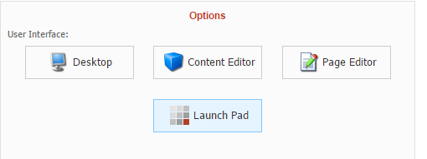

## Launch Pad

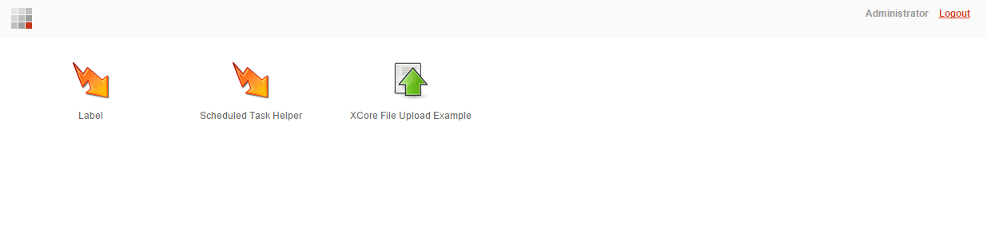

## Example Application

